**Future of smart phones**

**[1]Anushree S J,** BE Student, Department Of Computer Science and Engineering,

[1]Dayananda Sagar Academy Of Technology And Management, Bangalore-560082

Karnataka, India

[1][anushreesj@gmail.com](mailto:anushreesj@gmail.com)

***Abstract***

***From the very first advent of mobile phones, the technology has seen swift. The first phone was designed by Motorola in 1973. It hit the markets in 2000. In its clear space of invention and exploration, it is been used for more than just phone calls and messaging. Its breaking the ground for today and promising better technologies for tomorrow. About 179 billion mobile applications are downloaded per year. The paper goes through various trends in the smart phone technology that will be seen in the near future. The paper mainly focus on Augmented technology, Electro vibration technology, n-peg power generation. The currently in use applications are mentioned(Crayola, House craft).These technologies will surely leave us in awestruck. Finally it points out the major existing research in the advancement of smart phone development.***

***KEYWORDS****: Augmented technology, Electro vibration technology and n-peg, Crayola, House craft)*

# INTRODUCTION

Advanced technology is indistinguishable from magic. Mobile phones have been influencing our lives for a decade now. Digital world has more to give to make our lives better.Smart phones might itself be out-sourced and be some kind of wearable devices.Smart phones can be expected to be much more advanced in not only appearences but additional sensors.It would not be surprising if the machine can detect the what the human brain intends to do and performs the following. Augmented Reality is frivolous. Imagine conducting a meeting without a physical translator where the machine translates the language. AR feature can be used to simply get information fast and effectively by only pointing at a object. Flexible screens has always something to look for in the future using the Organic Light Emitting Diode(OLED technology). . The ability to give “characteristic touch feature “ in the touch pad is “Electro vibration technology. This will bring drastic changes in the online shopping in the future. Imagine using the physical energy that can be transformed into battery power. Using n-peg we’ll mostly never run out of mobile battery. The 3 of these technologies are described below.

1.Electro vibration technology:

In 1950, Edward Mallinckrodt, a researcher discovered the phenomenon of electro vibration. He noticed that the brass electric light socket had a different texture when light was burning. Texture sensing is the ability of robot end effecter to determine whether a surface is smooth or rough. Electro vibration could make for a better sensory experience on a smooth surface. In 1950, Edward Mallinckrodt, a researcher discovered the phenomenon of electro vibration.

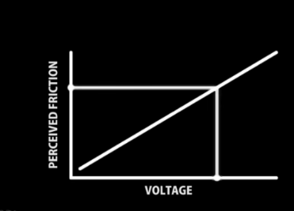

He noticed that the brass electric light socket had a different texture when light was burning. Texture sensing is the ability of robot end effecter to determine whether a surface is smooth or rough. Electro vibration could make for a better sensory experience on a smooth touch surface. One of these groups, composed of researchers from Disney Research in Pittsburgh, Carnegie Mellon University, and the University of Paris Sud, presented a paper at the [User Interface Software and Technology (UIST) symposium in New York City](http://www.acm.org/uist/uist2010/index.html). In the paper, they described their approach to electro vibration, called TeslaTouch, in which they modified a commercial touch panel from 3M that uses capacitive sensing – the approach used in most mobile phones and in the iPad. [Senseg](http://senseg.com/technology/senseg-technology)[1] has also implemented electro vibration in touch screens.  Patents for electro vibration; each outlines a different approach. Currently, the Disney demonstration only provides the feeling of texture when a finger is moving, although the group is working on a way to give feedback to a still finger.

Another limitation of the Disney prototype is that it provides only a single sensation at a time. However, it is possible to split up the screen in various ways to generate different sensations in different parts of the screen, but the design of such a screen would most likely depend on the specific application. Disney researchers showed a range of demos to illustrate TeslaTouch, including a simulated ice-covered window that changes friction as virtual ice is removed and a racetrack that provides different sensation as a finger traverses varying terrain. On hand to test the system was [Patrick Baudisch](http://www.patrickbaudisch.com/), professor of computer science at the [Hasso Plattner Institute](http://www.hpi.uni-potsdam.de/) in Potsdam, Germany. [2]An alternative approach to actuation of the touch surface is to decouple the tactile and visual displays. In the case of mobile devices, tactile feedback can be provided by vibrating the backside of the device, stimulating the holding hand. Alternatively, it is possible to embed localized tactile actuators into the body of a mobile device or into tools used in conjunction with touch interfaces . This approach, however, breaks the metaphor of direct interaction, requires external devices and still does not solve the problem of developing tactile feedback for large surfaces.

2. Augmented Reality:

Augmented reality superimposes video, graphics, sound and other elements on real world things. As the name suggests, it aims to enhance the world around us and make it more interesting. To the uninitiated, just think about watching an NBA basketball game on television. The reality part is the ongoing game. This is augmented by the scores, tally and other information related to the game. **Augmented Reality 3D viewers** - allow users to place life-size 3D models in your surrounding with or without the use of trackers. **Augmented Reality browsers** - enrich your camera display with contextual data. You can literally point your Smartphone at a house or building to estimate its value or to display its history. **Augmented Reality gaming** The biggest use of AR gaming to-date is definitely Pokémon Go, allowing users to catch virtual Pokémon creatures that are hidden throughout a map of the real environment.[3] Development of augmented reality training simulator systems for Neurosurgery using Model-Driven software Engineering Hamza Ghandorh,Justin Mackenzie and Roy Eagleson Western Universities, London, N6A3K7,Cannada presented a paper in 2010 which makes use of the Hierarchical Task Analysis(HTA). It derives two main case studies implemented using MDE (model driven engineering process. AR visualizes spatial and anatomical information about the image that is scanned using a smart phone and it gives a overall view.

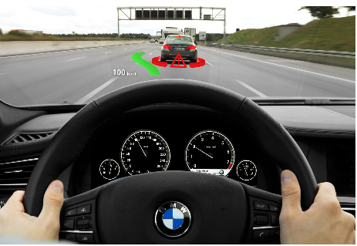

The above figure transforms the screen to heads up display which shows navigation information, safety alerts. [4]Car driving application which is implemented to verify the effectiveness of the proposed system. The implementation process is as follows: First, a projector projects a track image on the tabletop, and a smart phone augments a 3D virtual car model selected by a user on the physical object.

The “eye map” app gives the players James bond feel. It integrates AR with your device’s camera to determine your location and list geographical facts about the “Crayola’s color alive” app forth little ones entertained with Crayola’s newest and coolest AR project. With interactive color pages available on their webpage, you simply choose a design and color it however you want. Then, using the Color Alive app, simply scan your picture and watch it come to life with AR animation right on your screen. The house craft is used to design the interiors of a building. Scan any room or backyard with your phone’s camera, and then use Housecraft’s vast database of furniture, plants, objects, and home décor items to design the room of your dreams. You can adjust the sizing of the items too, so will you know the exact dimensions you’ll need before heading to the furniture store. Augmented Reality certainly has the capability to change the future. From marketing, to social media, to gaming, AR has been able to make great strides in the newest tech. These apps are certainly making a name for themselves in the tech world.

3.N-peg Generation:

The reality of the nPower PEG, a personal energy generator that, like battery-less flashlights which require shaking to produce energy, puts Michael Faraday's (1791– 1867) Principle of Electromagnetic Induction to work to create a totally renewable energy source for charging your handheld electronic devices. The 9" long, 9 ounce device from Tremont Electric works when you are in motion - just plug in your mobile device, place the nPower PEG vertically in your bag or on your hip and go for a walk or run. The kinetic energy from this movement is harvested to deliver charge at the same rate as a wall charger. This translates to an 80% for most devices in an hour of walking according to the company. Interchangeable adapters are available for charging over 90% of handheld electronic devices - media players, phones, digital cameras and GPS units. There are also plans for a range of arm bands and belt clips to hold the charger while you're on the move.[5] The mechanical energy which is available in form of pressure generated by shoes can power a computer, serving as an innovative energy power source for wearable energy harvesters.

The nPower PEG is the world's first passive kinetic energy charger for handheld devices, and it's now available. Built in the USA, the nPower PEG is compatible with over 3,000 commonly used handheld devices, via one of the iGo adapter tips. Some of the compatible devices include cell phones, cameras, music players, and GPS systems.

The PEG is a product from kinetic energy harvesting specialist Tremont Electric and the nPower technology is **scalable** both up and down in size and will eventually power a product range which extends from small, **implantable biomedical** generators to large commercial scale wave energy converters that sit in the ocean. [6]The voltage and power generation by piezo is not very high though instantaneous power generated from piezo with application of vibration or mechanical strain is moderate.

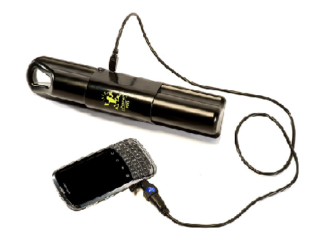

II CONCLUSION:

The applications that are most obvious involve honing electro vibration so it could be used to more easily draw and paint on a smooth touch surface. Electrovibration can be incorporated, finding a home in more unusual applications, such as large surfaces like wallpaper, and conformable materials like cloth. Hepatics in addition to tactile feedback gives a feel to objects.

AR is the boom technology the thought of having a meeting where all the business 3D graphs are floating in air itself is interesting. That is the representation of data is holographic and displayed in AR at the center of the table. Everybody will be surprised when the obvious and inevitable happens -- when the capabilities and performance of AR on phones and tablets becomes the reason to buy one brand of phone over another. Smartphone makers will then innovate with new hardware features to boost AR.

The most priced topic in discussions is how the advancement in technology is making humans lazy. n –peg power will remove that mole mostly forever. Humanity will start to believe technology is making us fit after all. It's clearly a very useful tool when you're off the beaten track and has great potential in countries where mobile devices are becoming more prevalent but a reliable supply of mains power is still a big problem. It's a completely recyclable product.

III REFERENCES:

[1] Perceiving texture gradients on an electrostatic friction display, **Published in:**[World Haptics Conference (WHC), 2017 IEEE](https://ieeexplore.ieee.org/xpl/mostRecentIssue.jsp?punumber=7980535) [Roberta L. Klatzky](https://ieeexplore.ieee.org/search/searchresult.jsp?searchWithin=%22Authors%22:.QT.Roberta%20L.%20Klatzky.QT.&newsearch=true),[Sara Adkins](https://ieeexplore.ieee.org/search/searchresult.jsp?searchWithin=%22Authors%22:.QT.Sara%20Adkins.QT.&newsearch=true),[Prachi Bodas](https://ieeexplore.ieee.org/search/searchresult.jsp?searchWithin=%22Authors%22:.QT.Prachi%20Bodas.QT.&newsearch=true),Carnegie Mellon University, Pittsburgh, PA, USA

[2] TeslaTouch: Electrovibration for Touch Surfaces Olivier Bau, Ivan Poupyrev , Ali Israr, Chris Harrison.

[3] Development of augmented reality training simulator systems for neurosurgery using model-driven software engineering by [Hamza Ghandorh](https://ieeexplore.ieee.org/search/searchresult.jsp?searchWithin=%22Authors%22:.QT.Hamza%20Ghandorh.QT.&newsearch=true)

[Justin Mackenzie](https://ieeexplore.ieee.org/search/searchresult.jsp?searchWithin=%22Authors%22:.QT.Justin%20Mackenzie.QT.&newsearch=true),[Roy Eagleson](https://ieeexplore.ieee.org/search/searchresult.jsp?searchWithin=%22Authors%22:.QT.Roy%20Eagleson.QT.&newsearch=true),London, N6A3K7, Canada.

[4]Interactive Augmented Reality system using projector-camera system and smart phone by Changmin Lim,Junyeong Choi,Jong-li Park at Madrid in 2015.

[5] Design & Implementation of Energy Harvesting System using Piezoelectric Sensors Shailendra Kumar Dewangan Assistant Professor, Dept. of Electronics & Instrumentation Engg, CSIT, Durg, Chhattisgarh, India Abhas Dubey B.E. Scholar, Dept. of Electronics & Instrumentation Engg,

[6] Study on Piezoelectric Elements for Energy Harvesting Nilotpal Manna Department of Electronics and Instrumentation Engineering lIS College of Engineering Kalyani 2017.